# MODULE: 4 (JavaScript Basic & DOM)

* What is JavaScript?

Ans:- JavaScript is a client side Scripting Language Jo Website ko dynamic banane k liye use karte he. Or isko Clinet Side Isliye bolte he kyo k jo bhi hum changes karte he vo sirf clinet side hi dekh sakta he.

{JavaScript is a lightweight interpreted programming language that web developers commonly use to create more dynamic interactions when developing web pages, applications, servers and or even games.}

* What is the use of isNaN function?

Ans:- NaN is a short form of Not A Number. Since Nan always compares unequal to any number, including NaN, it is usually used to indicate an error condition for a function that should return a valid number.

When a string or something else is being converted into number and that cannot be done, then we get to see NaN.

* What is negative Infinity?

Ans:- Negative infinity means constant value that represent the lowest available value.

* Which company developed JavaScript?

Ans:- **Netscape** company developed JavaScript.

* What are undeclared and undefined variables?

Ans:- **Undeclared**:- It Occure when variable is declare but not assign a value. It is not a keyword.

**Undefined**:- It Occure when we try to access any Variable.

* Write the code for adding new elements dynamically?

Ans:-

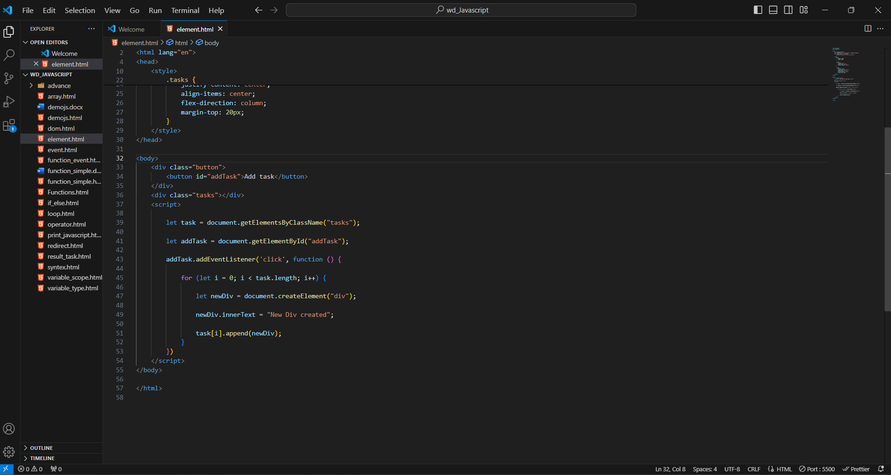

Output

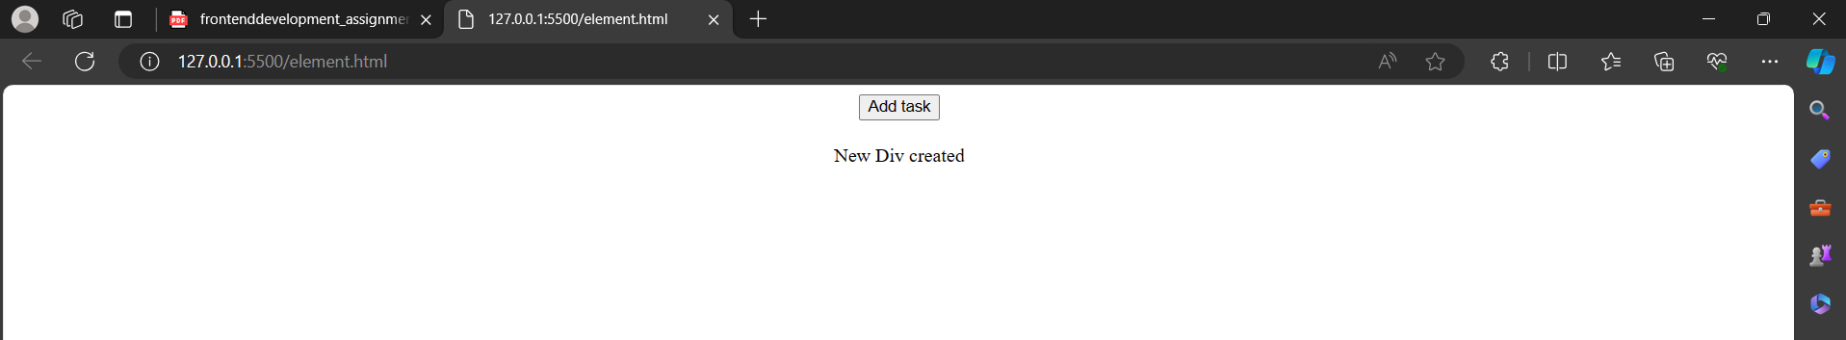

* What is the difference between ViewState and SessionState?

Ans:- **ViewState** :- It Specific to a single page in a session.

**SessionState**:- It is user specific that can access all the data on the page.

* What is === operator?

Ans:- The strict equality (===) operator checks whether its two operands are equal, returning a Boolean result. Unlike the [equality](https://developer.mozilla.org/en-US/docs/Web/JavaScript/Reference/Operators/Equality) operator, the strict equality operator always considers operands of different types to be different.

* How can the style/class of an element be changed?

ANs:-

document.getElementById("mytext").style.fontSize="25px"

document.getElementByClassName("mytext").className="class"

* How to read and write a file using JavaScript?

Ans:- On the client side, you can’t read or write files in JavaScript browsers. The fs module in Node.js may be used to accomplish this on the server-side. It has methods for reading and writing files on the file system that are both synchronous and asynchronous. Let’s demonstrate some examples of reading and writing files with the node.js fs module.

fs.readFile( file_name, encoding, callback_function )

fs.writeFile( file_name, data, options, callback )

* What are all the looping structures in JavaScript?

Ans:-

1. **For Loop**

let x;

for (x = 2; x <= 4; x++) {

console.log("Value of x: " + x);

}

1. **While Loop**

let val = 1;

while (val < 6) {

console.log(val);

val += 1;

}

1. **Do while Loop**

let test = 1;

do { console.log(test); test++;

} while(test <= 5)

1. **For in**

let myObj = { x: 1, y: 2, z: 3 };

for (let key in myObj) {

console.log(key, myObj[key]);

}

1. **For of**

let arr = [1, 2, 3, 4, 5];

for (let value of arr) {

console.log(value);

}

* How can you convert the string of any base to an integer in JavaScript?

Ans:-

Example

<script>

let stringConversion = (string_value) => {

console.log("Initial Type: " + typeof string_value);

let integer_value = parseInt(string_value);

console.log("Final Type: " + typeof integer_value);

console.log(integer_value);

};

stringConversion("512000");

stringConversion("126410");

stringConversion("0x8975");

</script>

**Output**

Initial Type: string

Final Type: number

512000

Initial Type: string

Final Type: number

126410

Initial Type: string

Final Type: number

35189

* What is the function of the delete operator?

Ans:-

Exapmle

let emp = {

firstName: "Arun",

lastName: "Yadav",

salary: 40000

}

console.log(delete emp.salary);

console.log(emp);

**Output**

true

{ firstName: ‘Arun’, lastName: 'Yadav' }

* What are all the types of Pop up boxes available in JavaScript?

Ans:-

**Alert Box**: It is used when a warning message is needed to be produced. When the alert box is displayed to the user, the user needs to press ok and proceed.

Syntax:

alert("your Alert here")

**Prompt Box**: It is a type of pop up box which is used to get the user input for further use. After entering the required details user have to click ok to proceed next stage else by pressing the cancel button user returns the null value.

Syntax:

prompt("your Prompt here")

**Confirm Box**: It is a type of pop-up box that is used to get authorization or permission from the user. The user has to press the ok or cancel button to proceed.

Syntax:

confirm("your query here")

* What is the use of Void (0)?

Ans:- The void 0 is used to call another method without refreshing the page during the calling time parameter “0” will Pass.

* How can a page be forced to load another page in JavaScript?

Ans: In JavaScript, you can force a page to load another page by using the window.location object. There are a few methods to achieve this. To force a page to load another page in JavaScript, we have multiple approaches: Below are the approaches used to force a page to load another page in JavaScript:

* What are the disadvantages of using innerHTML in JavaScript?

Ans:- The use of innerHTML very slow: The process of using innerHTML is much slower as its contents as slowly built, also already parsed contents and elements are also re-parsed which takes time. Preserves event handlers attached to any DOM elements: The event handlers do not get attached to the new elements created by setting innerHTML automatically.